Proposed Research Paper

Explainable Machine Learning for Stage-Aware Water-Stress Assessment in Kiwifruit cv. Allison

Abstract
Efficient irrigation management in kiwifruit requires consideration of both plant water status and phenological development because the consequences of water limitation can vary substantially among developmental stages. Conventional irrigation scheduling generally relies on soil moisture measurements and predetermined irrigation thresholds, whereas physiological indicators may provide additional information regarding plant responses to water limitation. In this study, an explainable machine-learning framework was developed to classify experimentally imposed water-stress conditions in kiwifruit cv. Allison using physiological indicators and phenological information. A dataset comprising 36 observations distributed across four phenological stages (S1–S4) and three experimental irrigation conditions was reconstructed from the original experimental records. Sixteen biological variables were assembled, with leaf proline and potassium selected as the primary physiological indicators for machine-learning analysis. The experimental irrigation conditions were represented as three ordered stress categories: Low, Moderate and High. Five classification algorithms—multinomial logistic regression, linear discriminant analysis, random forest, extra trees and radial-basis-function support vector machine—were evaluated using repeated stratified five-fold cross-validation and independent five-fold out-of-fold prediction. All evaluated models achieved perfect classification for the present dataset, with balanced accuracy, macro-F1 and Matthews correlation coefficient of 1.00. SHAP-based interpretation identified proline and leaf potassium as the dominant predictors, while class-specific explanations indicated differences in their relative contribution across stress categories. The results demonstrate that physiological indicators can provide highly discriminative information for distinguishing experimentally imposed irrigation conditions in kiwifruit. However, because the stress classes were derived from experimental irrigation treatments and the sample size was limited, the findings should be regarded as proof-of-concept predictive evidence rather than definitive physiological stress diagnosis. The proposed explainable framework provides a foundation for developing stage-aware irrigation decision support after independent validation under larger multi-season field conditions.
Keywords: Kiwifruit; Actinidia; water stress; irrigation scheduling; proline; potassium; machine learning; SHAP; explainable artificial intelligence; precision horticulture.

1. Introduction
Water availability is one of the major environmental factors governing vegetative development, fruit growth and productivity in perennial fruit crops. In kiwifruit, irrigation management is particularly important because fruit development depends strongly on adequate water availability during critical developmental periods. Previous experimental research has demonstrated that the timing of water limitation can substantially modify fruit growth and quality. Miller et al. reported that early-season water stress produced the greatest effect on kiwifruit fruit growth, with fruit from early-stressed vines being approximately 25% lighter at harvest than fruit from control vines.
The relationship between irrigation and crop response is not necessarily uniform throughout the growing season. Controlled deficit irrigation has therefore been proposed as a phenology-dependent management strategy in kiwifruit production. Lagos et al. evaluated regulated deficit irrigation in kiwifruit and emphasized the importance of applying water according to crop phenological stages.
More recent work has reinforced the importance of stage-specific water management. He et al. demonstrated that the response of kiwifruit quality to soil-water-content thresholds depended on both the timing and magnitude of water restriction. Their study examined four developmental periods corresponding broadly to early vegetative development, flowering/fruit set, fruit growth and fruit maturation, and reported different responses among stages.
Recent physiological research has also indicated that water availability can be closely associated with fruit growth processes. Boini et al. showed that water availability influenced fruit vascular flows and growth potential in yellow-fleshed kiwifruit, emphasizing that irrigation requirements should be evaluated in relation to both soil water status and phenological phase.
Despite these advances, conventional irrigation scheduling often relies on fixed soil-moisture thresholds or predetermined irrigation regimes. Such approaches may not fully exploit plant physiological information. Physiological biomarkers such as proline and leaf potassium can provide complementary information regarding plant responses to water limitation. Integrating these indicators with machine learning may therefore provide a quantitative approach for identifying patterns associated with experimentally imposed water-stress conditions.
Machine learning is particularly attractive because physiological variables may interact nonlinearly and their relationships with irrigation conditions may not be adequately represented by a single threshold. However, predictive accuracy alone is insufficient for agricultural decision support. A grower or agronomist needs to understand why a model predicts a particular condition. Explainable artificial intelligence (XAI), particularly SHAP (SHapley Additive exPlanations), provides a framework for quantifying the contribution of individual predictors to model predictions.
Therefore, the present study developed an explainable machine-learning framework for kiwifruit cv. Allison based on the following conceptual pathway:
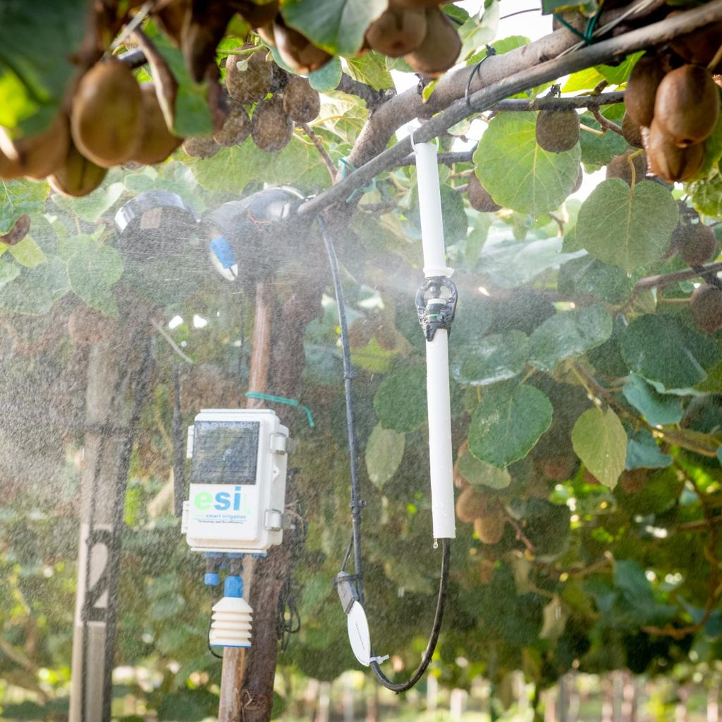
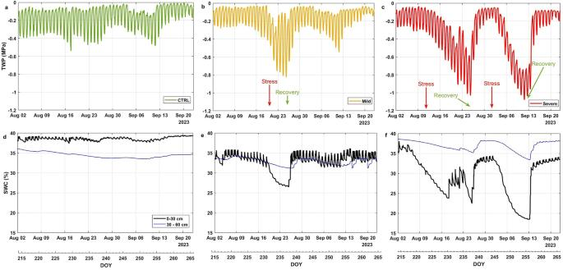
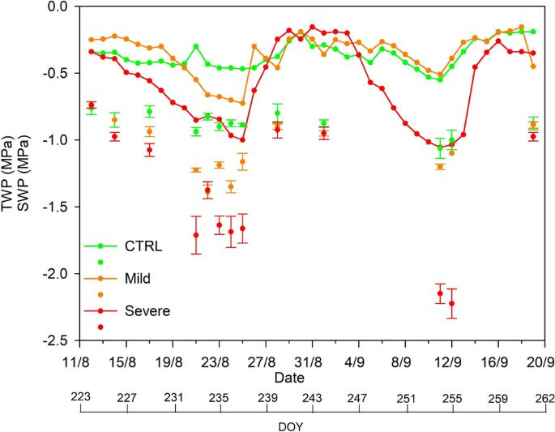
6
Kiwifruit cv. Allison → Soil Moisture Monitoring → Phenological Stage → Physiological Monitoring → Explainable Machine Learning → Water-Stress Condition → SHAP Explanation → Stage-Aware Irrigation Decision → Smart Irrigation Scheduling

Objectives
The specific objectives were:
- To construct a biologically consistent dataset from the experimental observations of kiwifruit cv. Allison.
- To evaluate proline and leaf potassium as physiological predictors of experimentally imposed irrigation conditions.
- To compare multiple machine-learning algorithms for three-class water-stress-condition classification.
- To quantify model performance using repeated cross-validation and out-of-fold predictions.
- To identify important physiological predictors using SHAP-based explainable artificial intelligence.
- To establish a framework for stage-aware irrigation decision support.

2. Materials and Methods

2.1 Experimental framework
The study was conducted within the experimental framework of the thesis project “Smart Irrigation Scheduling in Kiwifruit cv. Allison.” The experimental design incorporated irrigation treatments and four phenological stages. The thesis framework identifies four developmental stages:
- S1: Inflorescence emergence
- S2: Flowering
- S3: Fruit development
- S4: Fruit maturation
The experimental records contained three irrigation blocks designated I1, I2 and I3. The thesis protocol describes irrigation treatments corresponding to 80%, 65% and 50% field capacity; however, the raw analytical dataset uses the identifiers I1–I3, and the mapping should be explicitly verified against the original experimental protocol before publication as percentage field-capacity treatments.

2.2 Biological dataset reconstruction
The original experimental workbook consisted of separate worksheets for individual biological variables, including fruit weight, fruit length, fruit diameter, fruit shape ratio, yield, fruit number per vine, trunk cross-sectional area, trunk girth, yield efficiency, fruit volume, proline, leaf potassium, ascorbic acid and flowering-related variables.
Each worksheet contained experimental identifiers corresponding to irrigation treatment, phenological stage and replication. The datasets were reconstructed using the common experimental key:
Irrigation × Phenological Stage × Replication
This procedure produced a final dataset containing 36 observations and 16 biological variables.
The reconstructed variables were:
Category | Variables
Fruit characteristics | Fruit weight, length, diameter, shape ratio, volume
Yield | Yield, fruit count per vine, yield efficiency
Vegetative structure | TCSA, trunk girth
Physiological | Proline, leaf potassium, ascorbic acid
Phenological | Initial bloom, final bloom, bloom intensity
The reconstruction approach was important because the original spreadsheet contained structural columns that did not themselves represent biological measurements. The analytical dataset was therefore constructed from the actual measurement variables rather than spreadsheet-position variables.

3. Definition of the Machine-Learning Target
The machine-learning target was defined as experimental water-stress condition.
Three ordered categories were used:
- Low Stress
- Moderate Stress
- High Stress
The resulting dataset contained 12 observations per class, giving a balanced distribution of 33.33% for each class. The ML dataset contained no missing values for the selected predictors.
An important methodological distinction is that these categories represent experimental irrigation conditions, rather than independently measured physiological stress diagnoses. Therefore, throughout this manuscript the term water-stress condition refers to the experimentally imposed treatment-derived classification.
This distinction prevents the model from being interpreted as independently diagnosing plant water stress without an external physiological reference.

4. Physiological Predictors
Two primary physiological indicators were selected:

4.1 Proline
Proline is widely associated with plant responses to environmental stress and osmotic adjustment. In the present dataset, proline exhibited a pronounced separation among the three experimental stress conditions.
The observed mean values were approximately:
Condition | Proline
Low Stress | 1.75
Moderate Stress | 3.25
High Stress | 5.41
This monotonic pattern provides strong empirical evidence that proline contains substantial information about the imposed irrigation condition.

4.2 Leaf potassium
Leaf potassium also exhibited systematic differences among the experimental conditions:
Condition | Leaf potassium
Low Stress | 2.44
Moderate Stress | 2.36
High Stress | 2.29
Thus, proline and leaf potassium provided complementary physiological signals within the experimental dataset.

5. Machine-Learning Framework
Two predictor sets were evaluated.

Model A — Physiological model
Xphys={Proline, Leaf Potassium}X_{phys}=\{\text{Proline, Leaf Potassium}\}

Model B — Expanded biological model
Xexpanded={Proline,Leaf Potassium,TCSA,Trunk Girth,Initial Bloom,Final Bloom,Bloom Intensity}X_{expanded}= \{ \text{Proline}, \text{Leaf Potassium}, \text{TCSA}, \text{Trunk Girth}, \text{Initial Bloom}, \text{Final Bloom}, \text{Bloom Intensity} \}
The expanded set was designed to examine whether adding early biological and phenological variables improved classification beyond the two primary physiological indicators.

6. Classification Algorithms
Five machine-learning algorithms were evaluated:
- Multinomial Logistic Regression
- Linear Discriminant Analysis
- Random Forest
- Extra Trees
- Support Vector Machine with radial basis function kernel
Standardization was applied where appropriate, while tree-based models were evaluated using their native feature representation.
The objective was not simply to identify the most complex model, but to determine whether the experimentally imposed conditions could be discriminated using a small and interpretable physiological feature set.

7. Cross-Validation Strategy
Because only 36 observations were available, conventional single train-test splitting could produce unstable estimates.
The primary performance evaluation therefore used:
Repeated Stratified 5-Fold Cross-Validation
with:
- 5 folds
- 10 repetitions
- 50 validation evaluations
- random state = 42
A separate stratified five-fold partition was used to generate out-of-fold predictions. This distinction prevented the repeated CV procedure from being incorrectly combined with cross_val_predict. The corrected analysis explicitly separates performance estimation from OOF prediction.
Performance was evaluated using:
- Accuracy
- Balanced Accuracy
- Macro-F1
- Matthews Correlation Coefficient (MCC)
Balanced accuracy and macro-F1 were emphasized because they provide class-balanced performance measures.

8. Explainable Artificial Intelligence
SHAP was used to investigate the contribution of individual physiological variables to model predictions.
For a prediction f(x)f(x), SHAP decomposes the model output approximately as:
f(x)=ϕ0+∑j=1pϕjf(x)=\phi_0+\sum_{j=1}^{p}\phi_j
where:
- ϕ0\phi_0 represents the baseline model output,
- ϕj\phi_j represents the contribution of feature jj,
- pp is the number of predictors.
Global SHAP importance was calculated from the mean absolute SHAP contribution.
Class-specific SHAP analyses were also performed for:
- Low Stress
- Moderate Stress
- High Stress
The SHAP analysis was intended to answer a practical question:
Which physiological variables contribute most strongly to the model's classification of the experimental water-stress condition?
The analysis was interpreted as model explanation rather than causal inference.

9. Results

9.1 Dataset characteristics
The reconstructed dataset contained 36 observations, with:
- 3 irrigation conditions
- 4 phenological stages
- 3 replications
- 16 biological variables
The machine-learning target contained exactly 12 observations in each stress category. Both primary physiological predictors had complete observations.

9.2 Physiological separation of experimental conditions
A strong separation was observed for both physiological variables.
Proline increased progressively across the experimental conditions:
Low → Moderate → High
while leaf potassium showed the opposite pattern:
High → Moderate → Low
The combination of these two variables therefore provided a highly discriminative physiological representation of the experimental irrigation conditions.

10. Machine-Learning Performance
All five evaluated algorithms achieved perfect classification on the current dataset for both the physiological and expanded feature sets.
The reported repeated-CV performance was:
Feature set | Model | Balanced Accuracy | Macro-F1 | MCC
Physiological | Logistic Regression | 1.00 ± 0.00 | 1.00 ± 0.00 | 1.00 ± 0.00
Physiological | LDA | 1.00 ± 0.00 | 1.00 ± 0.00 | 1.00 ± 0.00
Physiological | Random Forest | 1.00 ± 0.00 | 1.00 ± 0.00 | 1.00 ± 0.00
Physiological | Extra Trees | 1.00 ± 0.00 | 1.00 ± 0.00 | 1.00 ± 0.00
Physiological | SVM-RBF | 1.00 ± 0.00 | 1.00 ± 0.00 | 1.00 ± 0.00
The same perfect performance was obtained for the expanded seven-feature representation. The original analysis reports balanced accuracy, macro-F1 and MCC of 1.0000 ± 0.0000 across the evaluated models.
The independent five-fold OOF analysis also produced:
Accuracy=1.00Accuracy=1.00 Balanced Accuracy=1.00Balanced\ Accuracy=1.00 Macro F1=1.00Macro\ F1=1.00 MCC=1.00MCC=1.00
for the selected physiological model.

11. Confusion Matrix
The five-fold out-of-fold predictions resulted in complete separation:
Actual / Predicted | Low | Moderate | High
Low | 12 | 0 | 0
Moderate | 0 | 12 | 0
High | 0 | 0 | 12
Thus, no observation was misclassified in the OOF evaluation.
However, because the sample size is small and the target is derived from experimental irrigation treatment, this result should not be interpreted as proof that the model will achieve 100% accuracy on independent orchards or future seasons.

12. SHAP-Based Interpretation
The global SHAP analysis identified proline and leaf potassium as the dominant predictors.
The global ranking was:
- Proline
- Leaf Potassium
This result is biologically meaningful because both variables showed substantial separation among the experimental irrigation conditions.
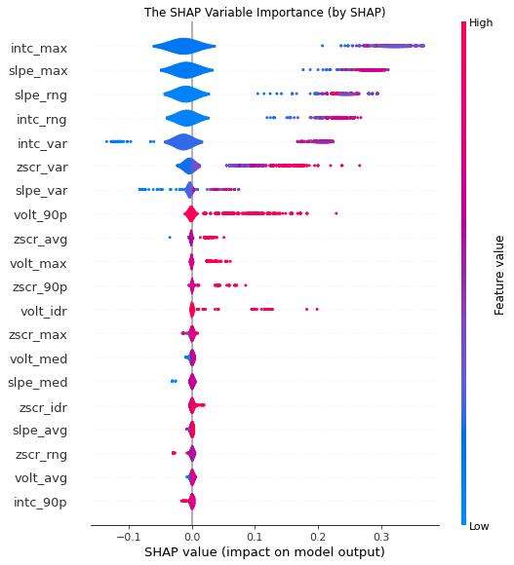
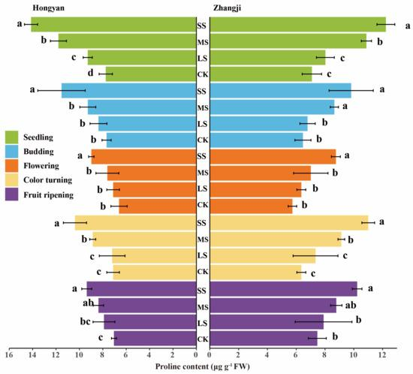
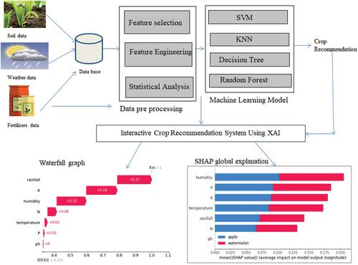
5

Class-specific interpretation
The class-wise SHAP analysis indicated that the relative contribution of the two physiological variables differed between stress categories.
- For Low Stress, proline showed the stronger contribution.
- For Moderate Stress, both variables contributed substantially.
- For High Stress, leaf potassium showed a particularly strong contribution in the class-specific analysis.
These differences suggest that the model does not necessarily use the same physiological signal with equal strength for every class.
Importantly, SHAP contributions should be interpreted as model-output contributions, not as evidence that changing a particular physiological variable will necessarily cause a plant to transition from one stress state to another.

13. Discussion

13.1 Physiological indicators can strongly discriminate experimental irrigation conditions
The strongest finding of this study is the substantial separation of the three experimental irrigation conditions using only two physiological variables.
Proline increased from approximately 1.75 in the Low Stress condition to 3.25 in the Moderate Stress condition and 5.41 in the High Stress condition. At the same time, leaf potassium decreased from approximately 2.44 to 2.36 and 2.29.
This complementary pattern explains why a relatively simple two-variable representation was sufficient to distinguish the experimental groups.
The result is consistent with the broader physiological principle that plants respond to water limitation through biochemical and ionic adjustments. Nevertheless, the present study demonstrates an association with the experimental treatment, rather than independently establishing a universal physiological threshold.

13.2 Why was 100% classification obtained?
Perfect classification deserves careful interpretation.
There are several possible explanations.
First, the physiological variables exhibit unusually strong separation between the experimentally imposed groups.
Second, the three classes were generated from controlled irrigation treatments rather than noisy field diagnoses.
Third, the sample is relatively small, containing only 36 observations.
Fourth, the experimental design may create structured differences that are easier to classify than naturally occurring water stress in commercial orchards.
Therefore, the result should be described as:
“perfect discrimination of the experimentally imposed irrigation conditions within the present dataset.”
It should not be written as:
“The proposed model detects water stress with 100% accuracy in kiwifruit.”
That stronger statement would exceed the evidence.

14. Relationship with Previous Kiwifruit Irrigation Research
The present framework complements previous research showing that water availability and its timing are important determinants of kiwifruit growth and quality.
Miller et al. demonstrated that early-season water stress can strongly reduce fruit growth, highlighting the importance of developmental timing.
He et al. subsequently demonstrated that soil-water-content thresholds produce stage-dependent effects on kiwifruit quality, with different developmental periods responding differently to water limitation.
Similarly, recent work on yellow-fleshed kiwifruit reported strong relationships between water availability and fruit growth potential and emphasized the importance of combining environmental and plant sensing for irrigation management.
These findings support the conceptual basis of the present study:
soil water status alone → limited information
versus
soil water + plant physiological response + phenological stage → richer decision information.

15. Stage-Aware Irrigation Decision Framework
The ultimate purpose of the framework is not merely classification.
The intended decision pathway is:
Soil Moisture+Phenological Stage+Physiological Indicators\text{Soil Moisture} + \text{Phenological Stage} + \text{Physiological Indicators} ↓\downarrow ML Water-Stress Classification\text{ML Water-Stress Classification} ↓\downarrow SHAP Interpretation\text{SHAP Interpretation} ↓\downarrow Stage-Aware Irrigation Decision\text{Stage-Aware Irrigation Decision} ↓\downarrow Smart Irrigation Scheduling\text{Smart Irrigation Scheduling}
The proposed system could eventually provide recommendations such as:
Soil/plant information | Model output | Decision-support interpretation
Adequate soil moisture + Low Stress | Low | Continue monitoring
Declining moisture + Moderate Stress | Moderate | Review irrigation timing
Low moisture + High Stress | High | Prioritize irrigation assessment
Moderate stress during sensitive stage | Moderate | Consider earlier intervention
High stress during fruit development | High | Avoid prolonged water limitation
These are decision-support concepts rather than experimentally validated irrigation prescriptions.

16. Proposed Smart-Irrigation Architecture
The complete conceptual architecture can be represented as:
Kiwifruit cv. Allison
↓
Soil Moisture Monitoring
↓
Phenological Stage
S1 → S2 → S3 → S4
↓
Physiological Monitoring
- Proline
- Leaf Potassium
↓
Explainable Machine Learning
↓
Experimental Water-Stress Condition
- Low
- Moderate
- High
↓
SHAP Explanation
↓
Stage-Aware Irrigation Decision
↓
Smart Irrigation Scheduling

Figure 1. Proposed explainable stage-aware irrigation framework for kiwifruit cv. Allison.
Your generated flow diagram is suitable as the conceptual Figure 1, but I would change its wording slightly for the journal paper: use “Experimental Water-Stress Condition” instead of simply “Water-Stress Condition,” and avoid claiming that the current model already produces an optimized irrigation schedule.

17. Limitations
Several limitations should be explicitly acknowledged.

17.1 Small sample size
The present analysis contains only 36 observations. Consequently, the perfect classification performance may not generalize to larger datasets.

17.2 Treatment-derived target
The target variable represents experimentally imposed irrigation conditions. It is not an independently validated physiological stress diagnosis.

17.3 Single experimental context
The dataset represents one experimental framework, cultivar and study environment. External validation across seasons, orchards, soils and climatic conditions is required.

17.4 No integrated image modality in the present analysis
Although the broader research concept includes leaf imaging, the current validated results are based on biological/agronomic measurements. Therefore, this paper should not claim multimodal image-plus-physiological learning until image features are actually integrated and independently evaluated.

17.5 Irrigation recommendation requires validation
The present results support a decision-support framework, not a finalized irrigation prescription. A practical scheduling system requires validation using soil-moisture measurements, plant responses, irrigation volumes, yield and fruit-quality outcomes.

18. Future Work
The next stage should strengthen the paper substantially by adding:
- Leave-One-Stage-Out validation
- Leave-One-Replication-Out validation
- Permutation testing
- Bootstrap confidence intervals
- Effect-size analysis
- Stage × irrigation interaction analysis
- Stage-specific physiological response analysis
- Counterfactual explanations
- Independent-season validation
- Integration of leaf-image features
The last item would allow the research to legitimately evolve into:
multimodal explainable machine learning combining physiological measurements and leaf-image information.

19. Conclusions
This study developed an explainable machine-learning framework for assessing experimentally imposed water-stress conditions in kiwifruit cv. Allison. Reconstruction of the experimental records produced a biologically consistent dataset containing 36 observations and 16 biological variables across three irrigation conditions and four phenological stages.
Proline and leaf potassium demonstrated strong separation among the experimental irrigation conditions and were sufficient to provide perfect classification within the present dataset. Five machine-learning algorithms achieved balanced accuracy, macro-F1 and MCC values of 1.00 in the current cross-validation analysis. SHAP interpretation identified proline and leaf potassium as the dominant predictors and provided class-specific information regarding their relative contribution.
The results demonstrate the potential of combining plant physiological indicators, machine learning and explainable artificial intelligence for precision irrigation research. However, the findings represent proof-of-concept classification of experimentally imposed irrigation conditions, rather than definitive diagnosis of physiological water stress or a validated universal irrigation schedule.
The proposed framework provides a foundation for developing a stage-aware smart irrigation system in which soil moisture, phenological stage and plant physiological responses are integrated into an explainable decision-support architecture. Larger datasets, independent validation and field-scale experiments are required before the framework can be translated into operational irrigation recommendations.

